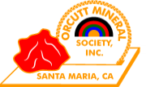
ORCUTT MINERAL SOCIETY, INC.

THE ANNUAL OMS GEM SHOW 2026

A QUICK LOOK BY WES LINGERFELT

IT WAS THE BIGGEST AND THE BEST WE HAVE EVER DONE!

LET’S START BY LOOKING AT THE DISPLAYS IN THE OLYMPIC HALL!

BEING A LAPIDARY JUDGE AT THREE STATE FAIRS, I WILL TRY NOT TO BE JUDGEMENTAL IN THIS REVIEW!

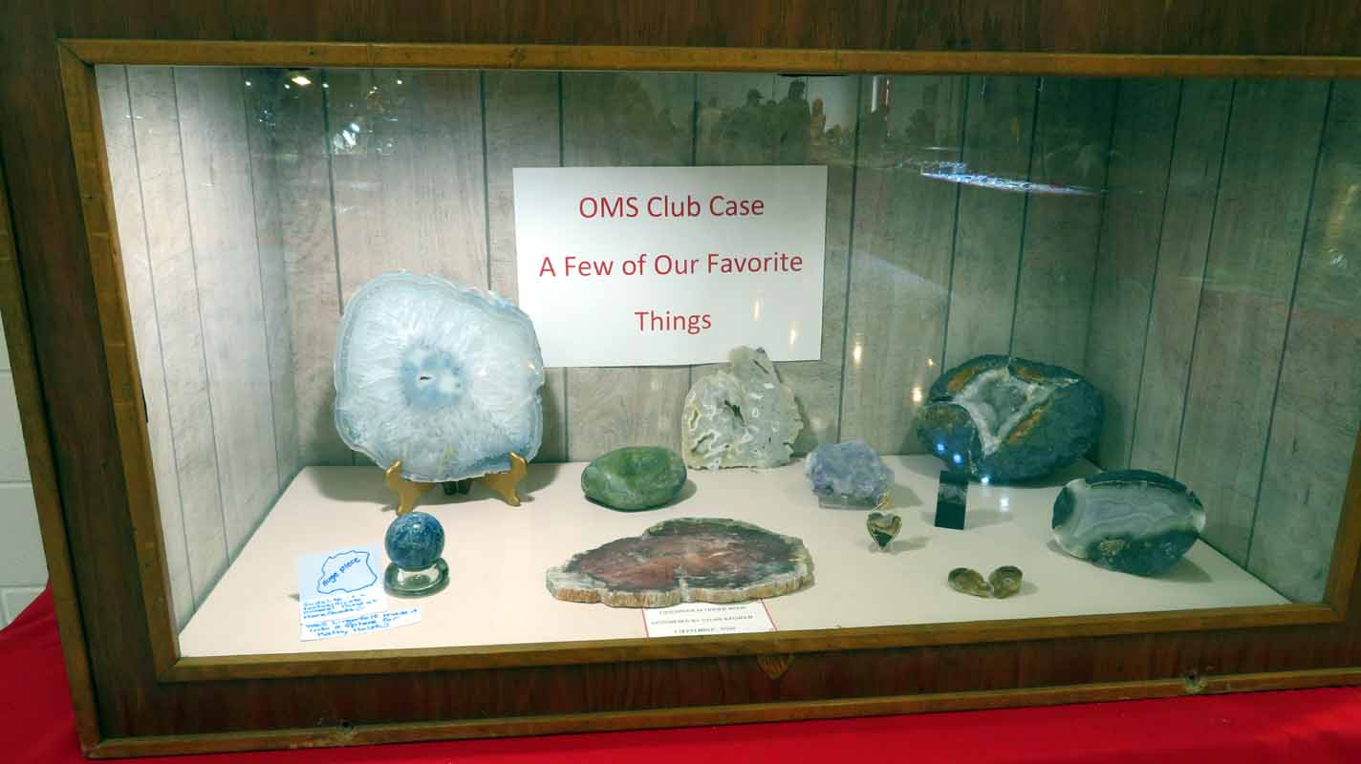
No. 1 OMS Members case. A well designed and displayed case.
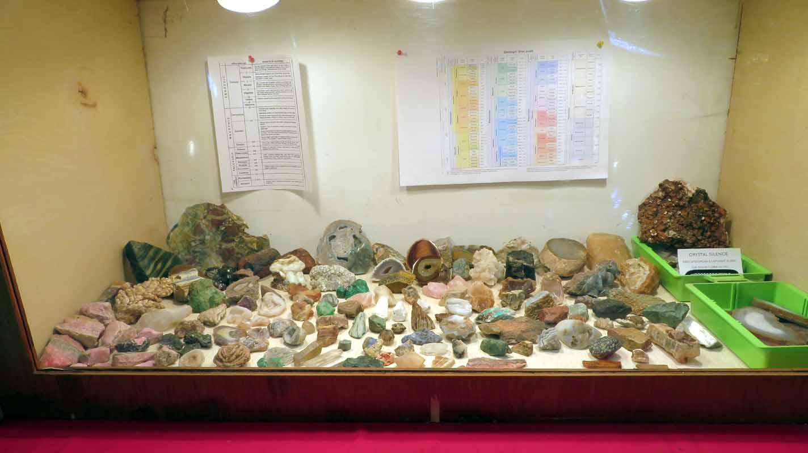No. 2 Interesting but too crowded! Text is not readable!
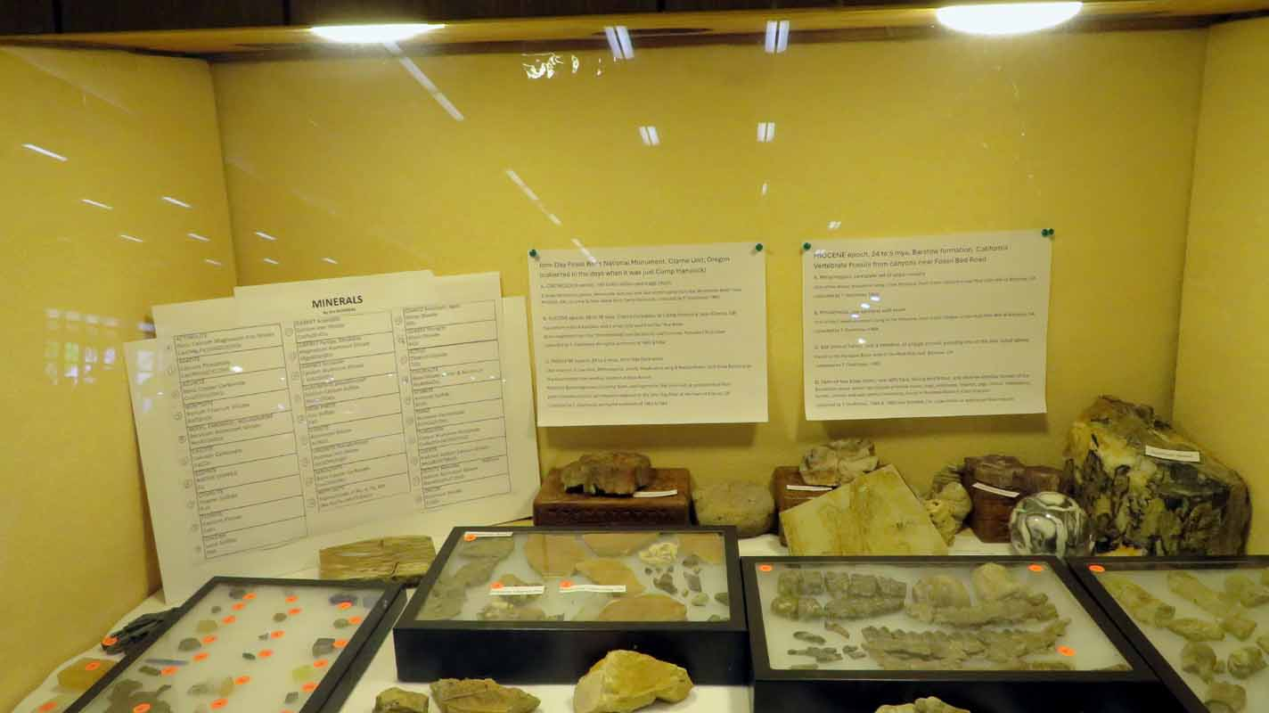
No. 3 A nice fossil case but too much information. Text could be larger for readability.

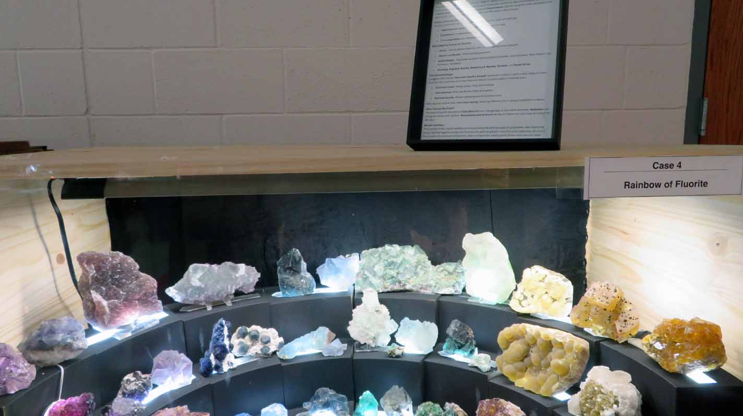
No. 4 An award winner case but I wonder if anyone read the text on top? I doubt it!
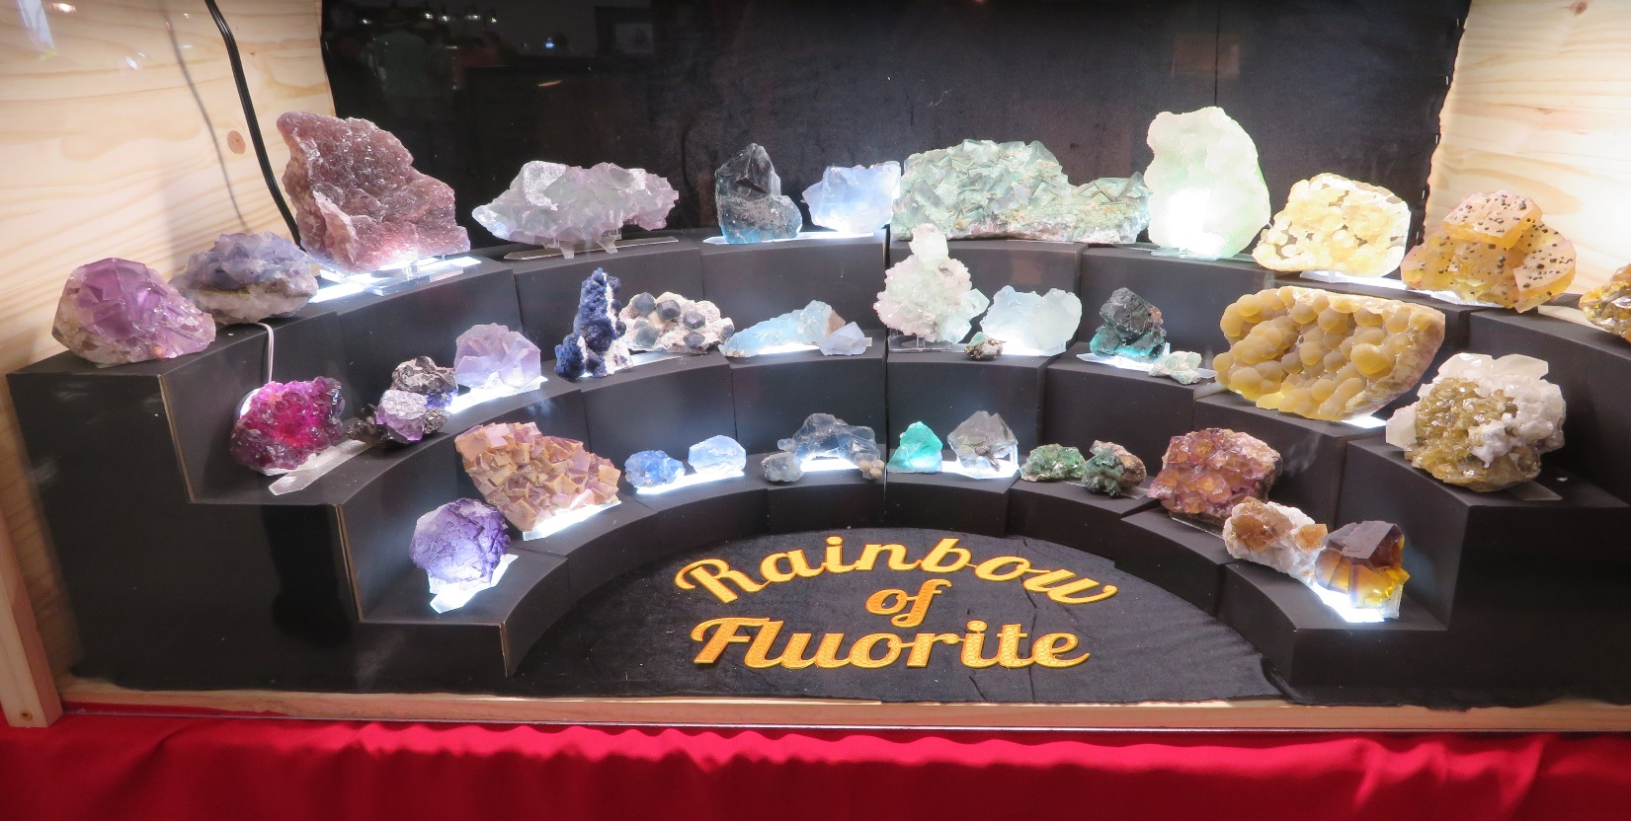
No. 4 again. A real eye catcher case!

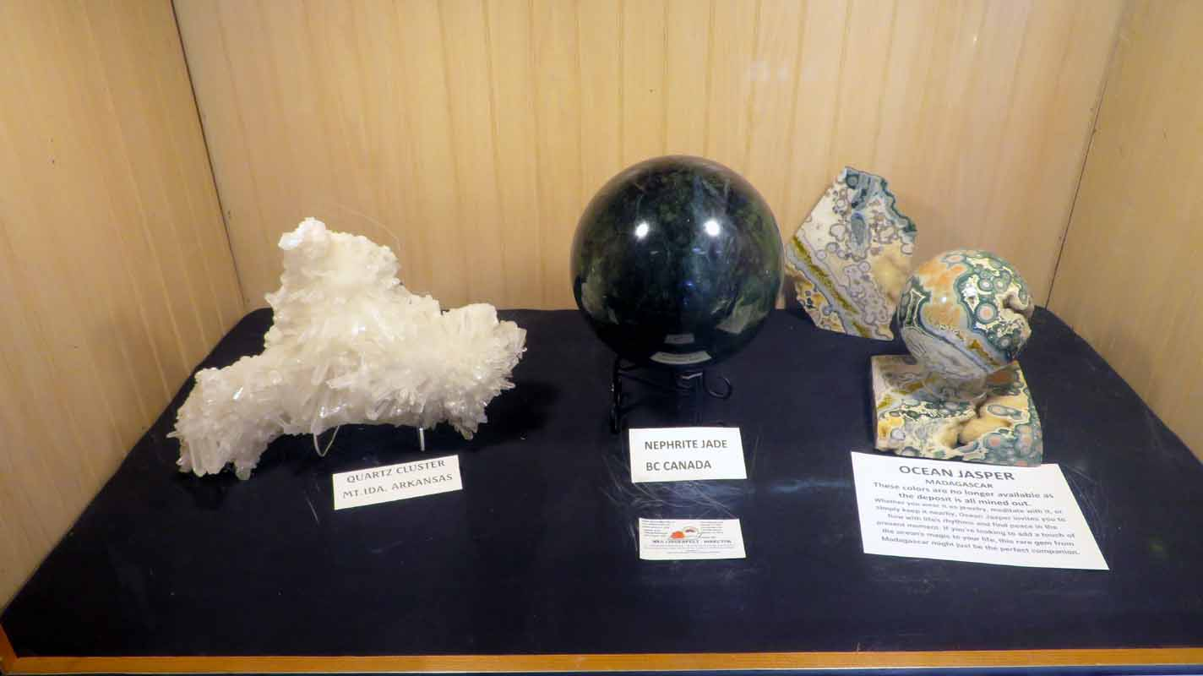
No. 5 Some of my treasures. Jeannie rejected a $10k offer for her Ocean Jasper!

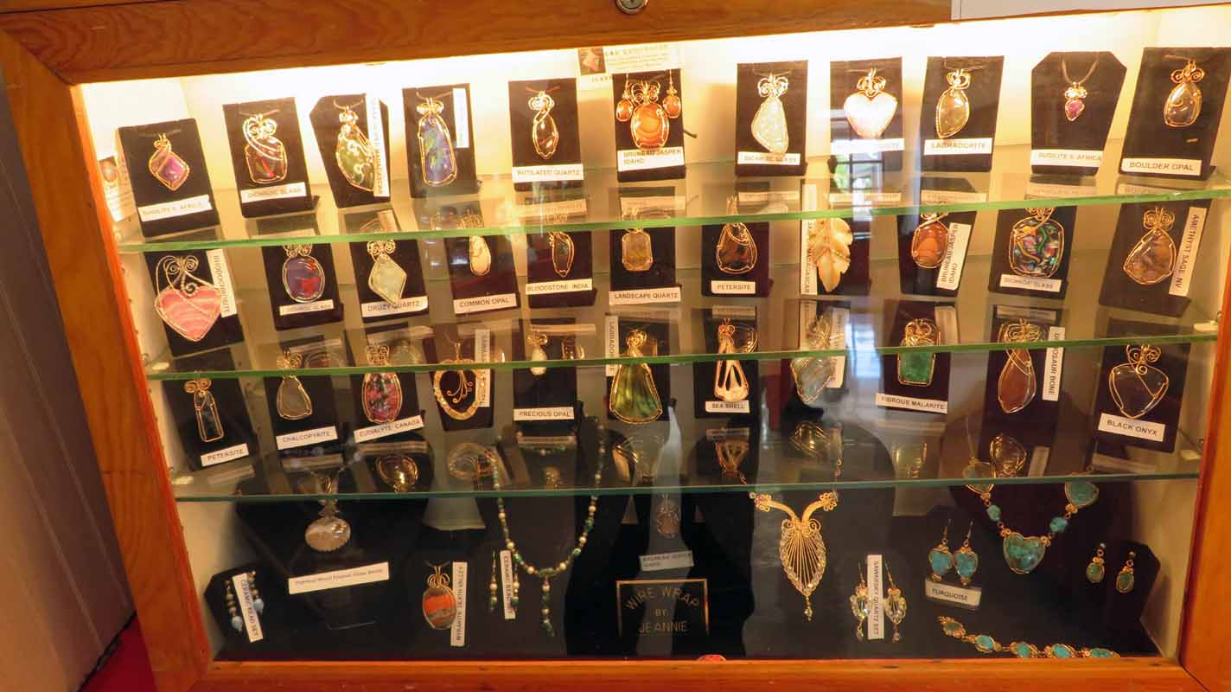
No. 6 Some of Jeannie’s handiwork! A true master wire wrapper! A Master gave her two lessons!

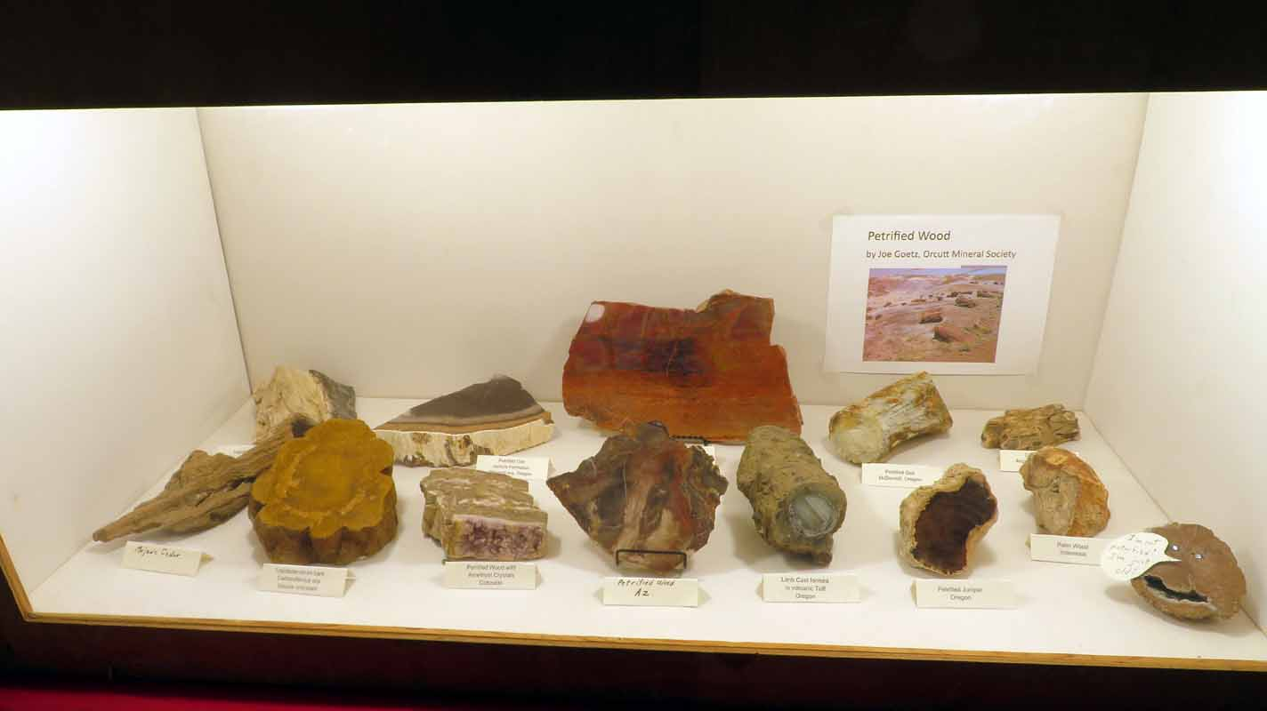
No.7 A good case, well balanced, good readable labels. Would rank high in competition.
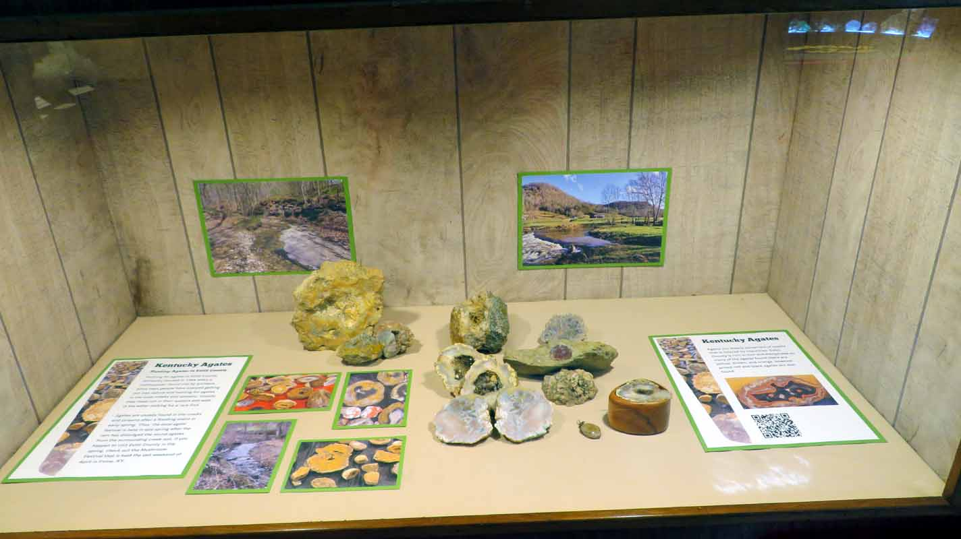
No. 8 Another good case. It too would rank high in Competition.

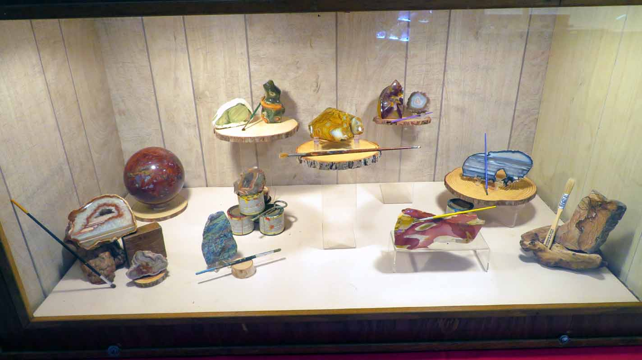

No. 9 Another good case but would lose points due to lack of labeling.
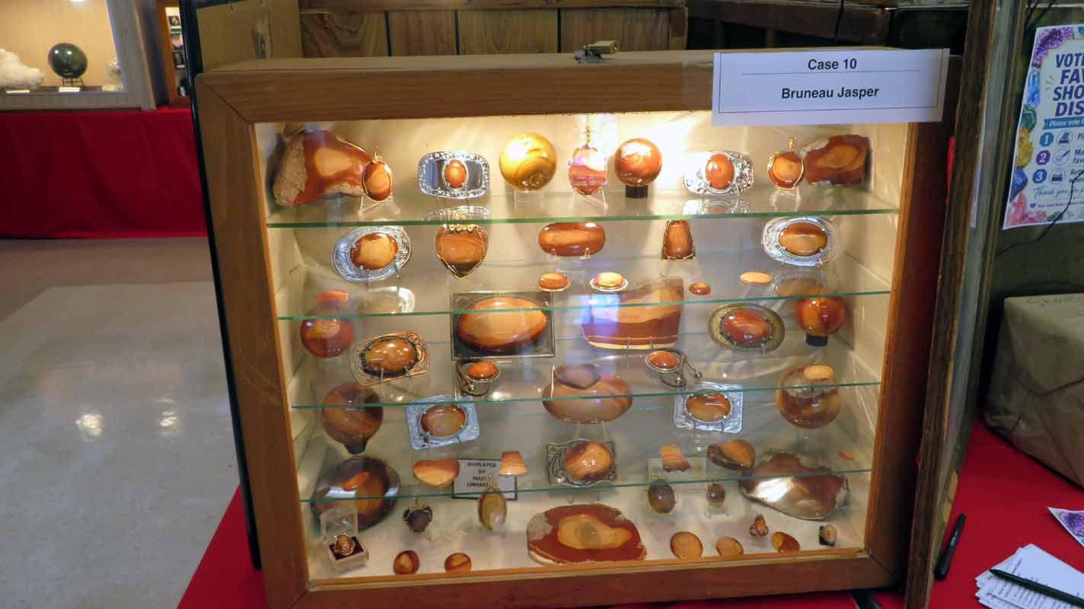
No. 10 A classic Memorial case for Member Buck Strader displayed by my Son Marty

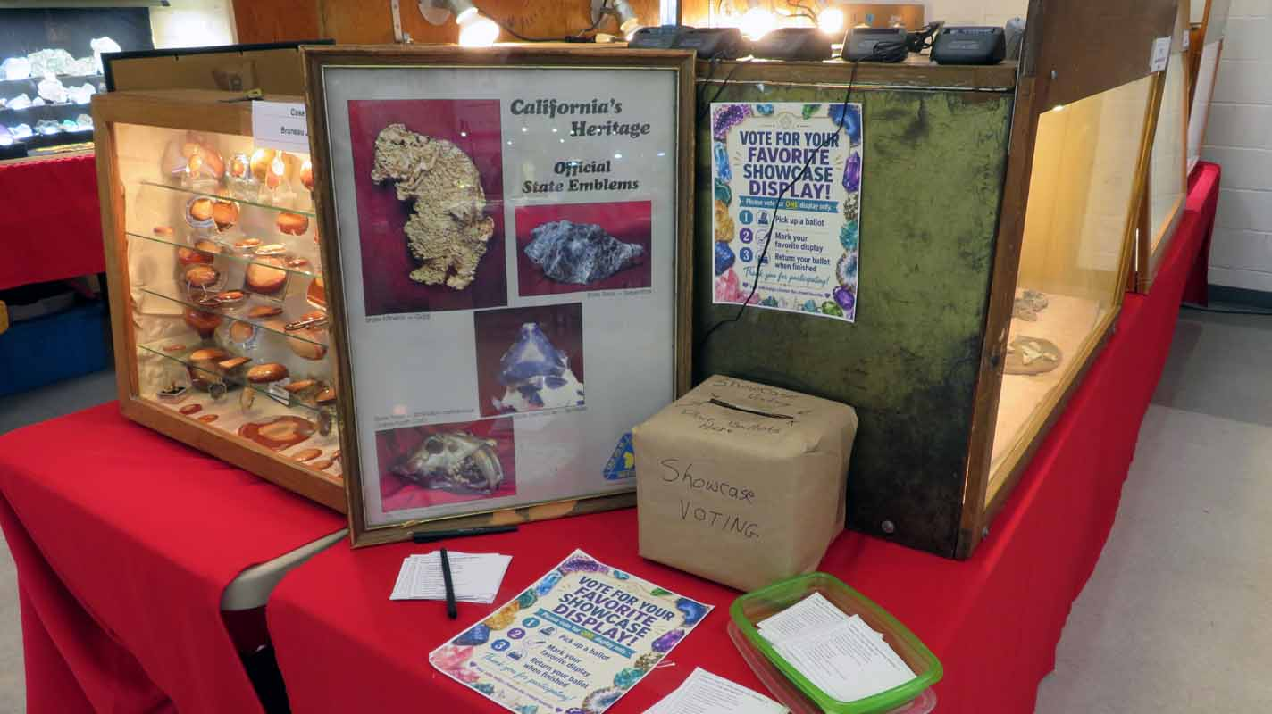
I never heard the results of the votes! I think I know who won! 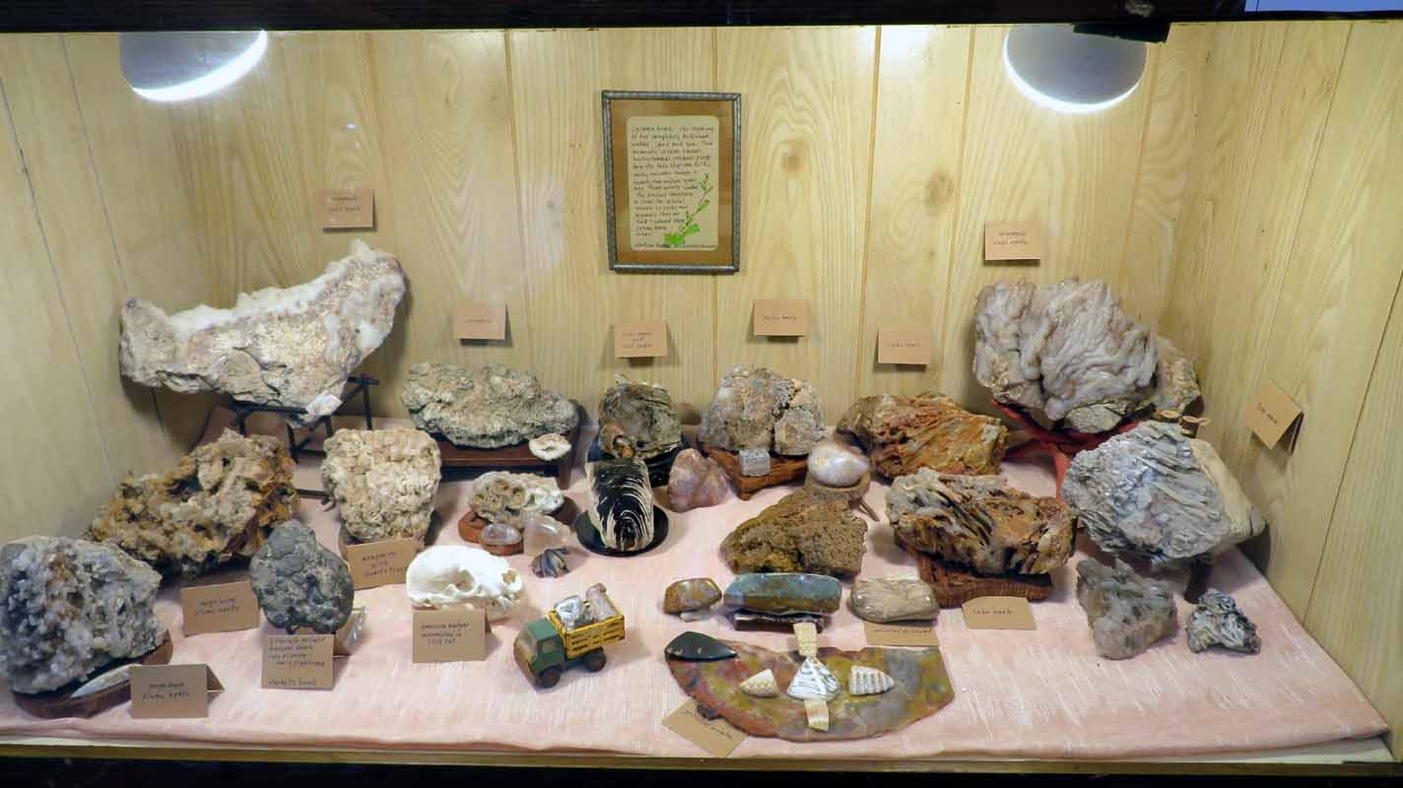

No. 11 Interesting Display but not ready for Competition! Too crowded, labeling detracts but a good start.

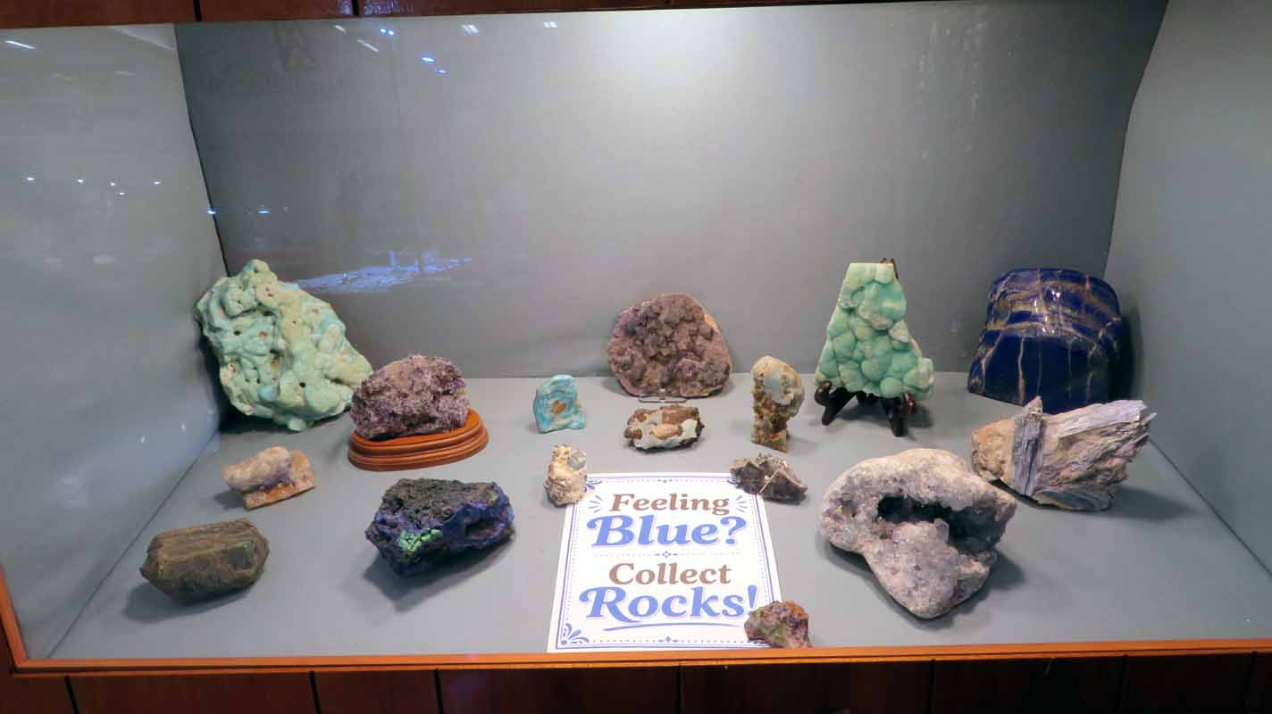
No. 12 A good case but additional labeling would improve competitive score.
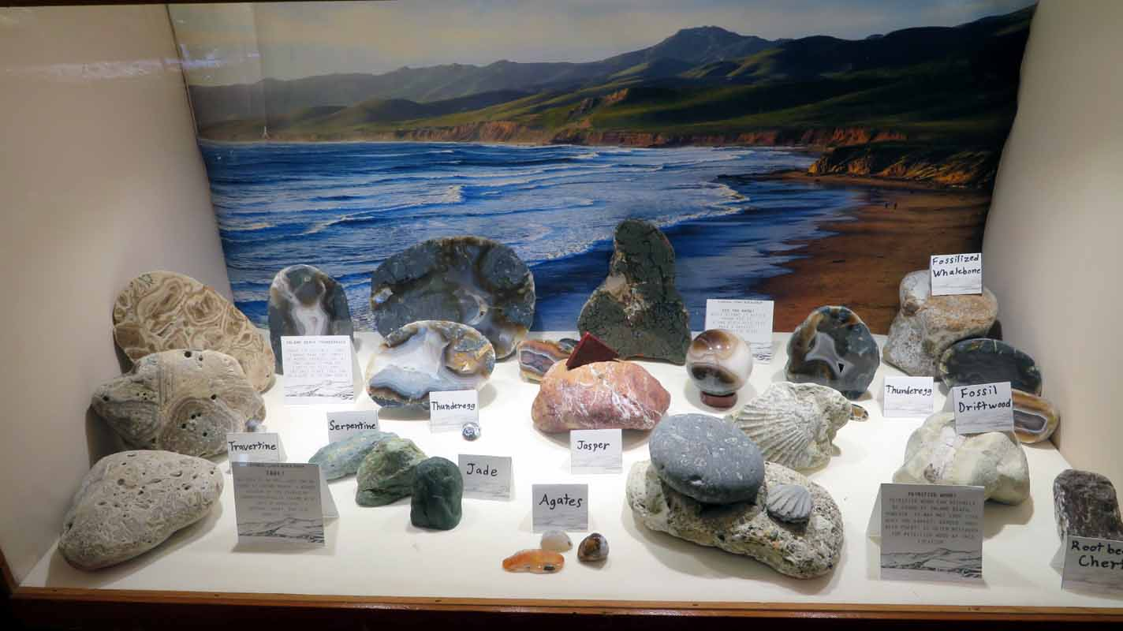
No. 13. Beautiful scenery but needs improvement for competition. Handwritten labels lose points. Not Balanced.

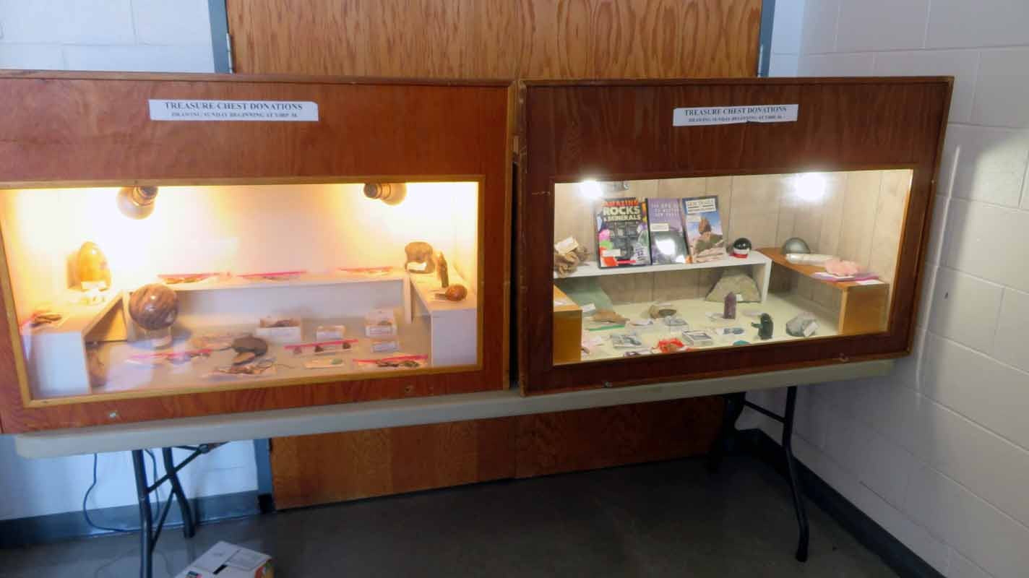
What’s wrong with this picture? I’ve been trying to teach people the proper setup for these cases for more than 30 years.
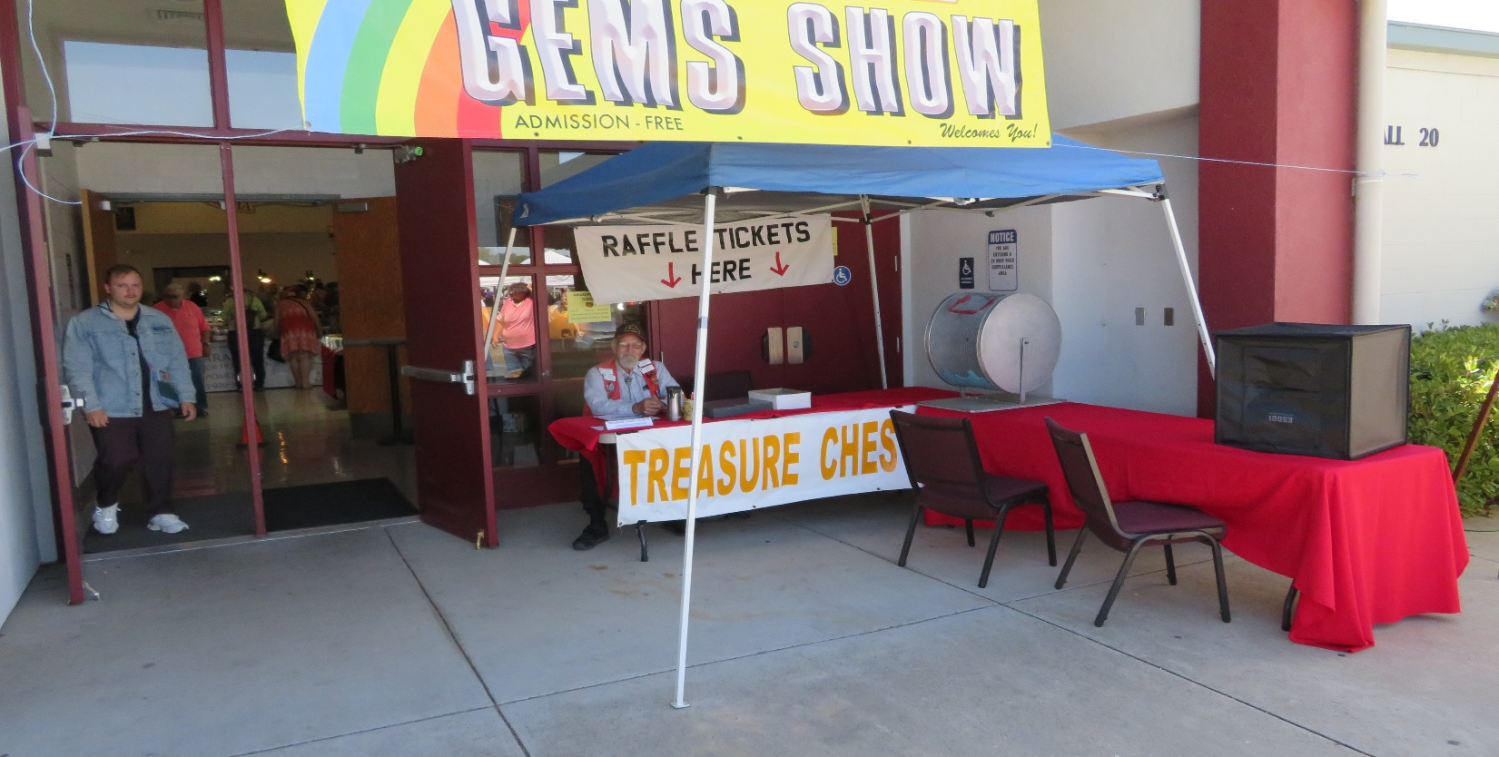
This was an excellent change for the show as it freed up the Ladies room. The Treasure Chest is no more!

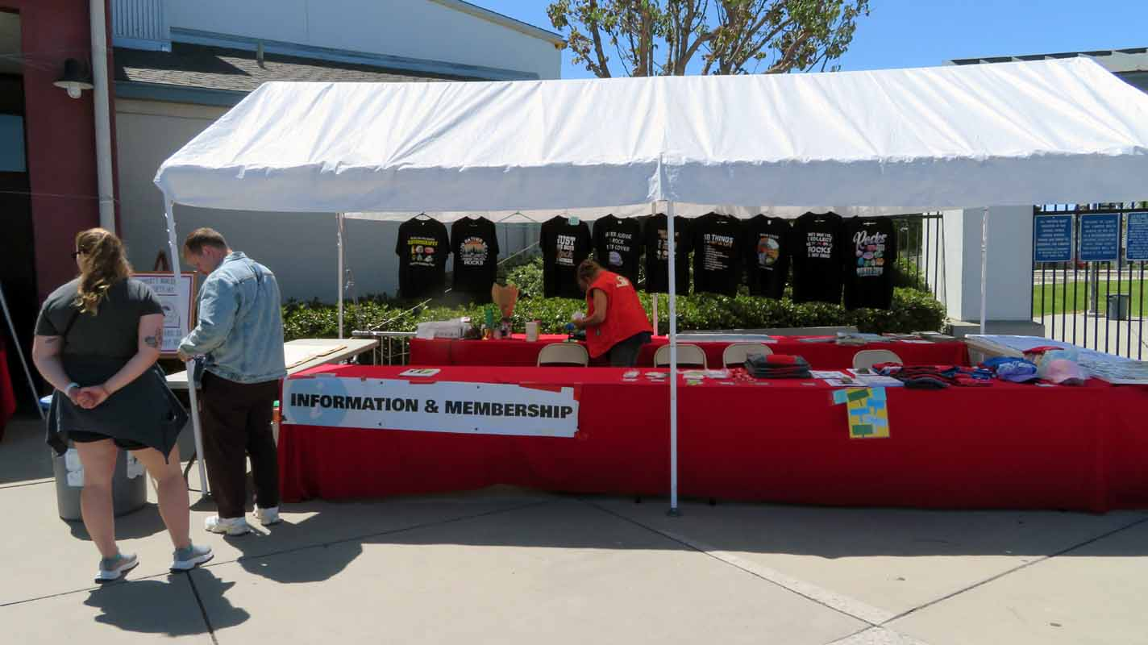
We had good sales on Tee Shirts and passed out lots of membership apps.
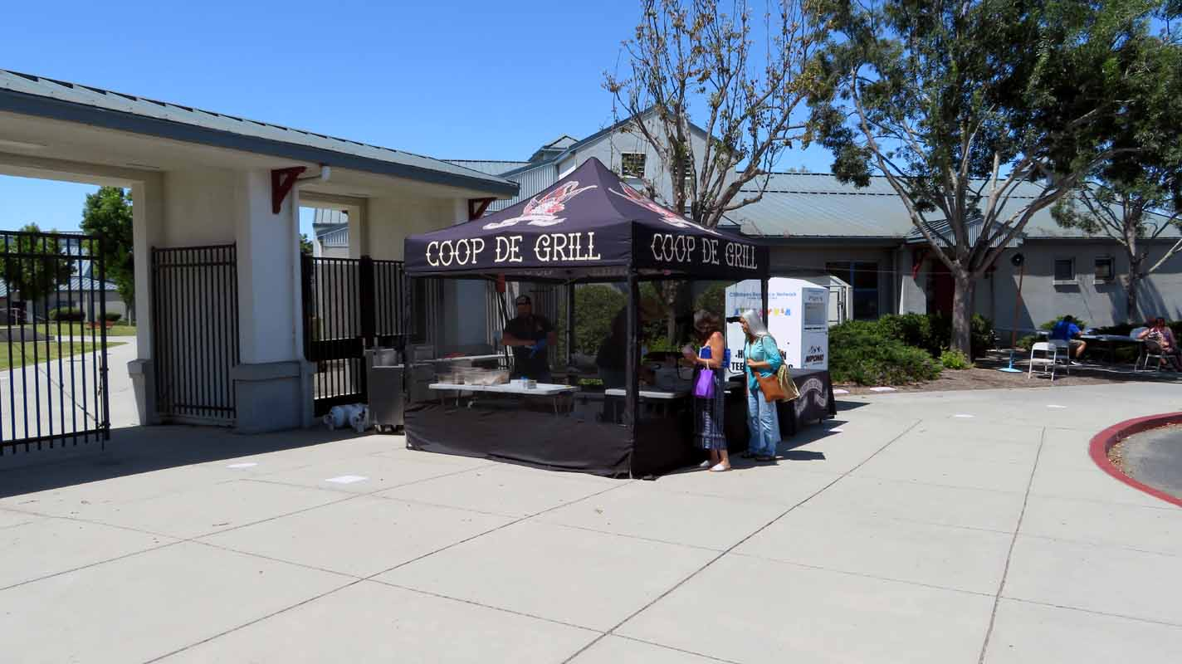
This food vendor was excellent, especially the fries and tenders. He did leave a mess on the sidewalk.

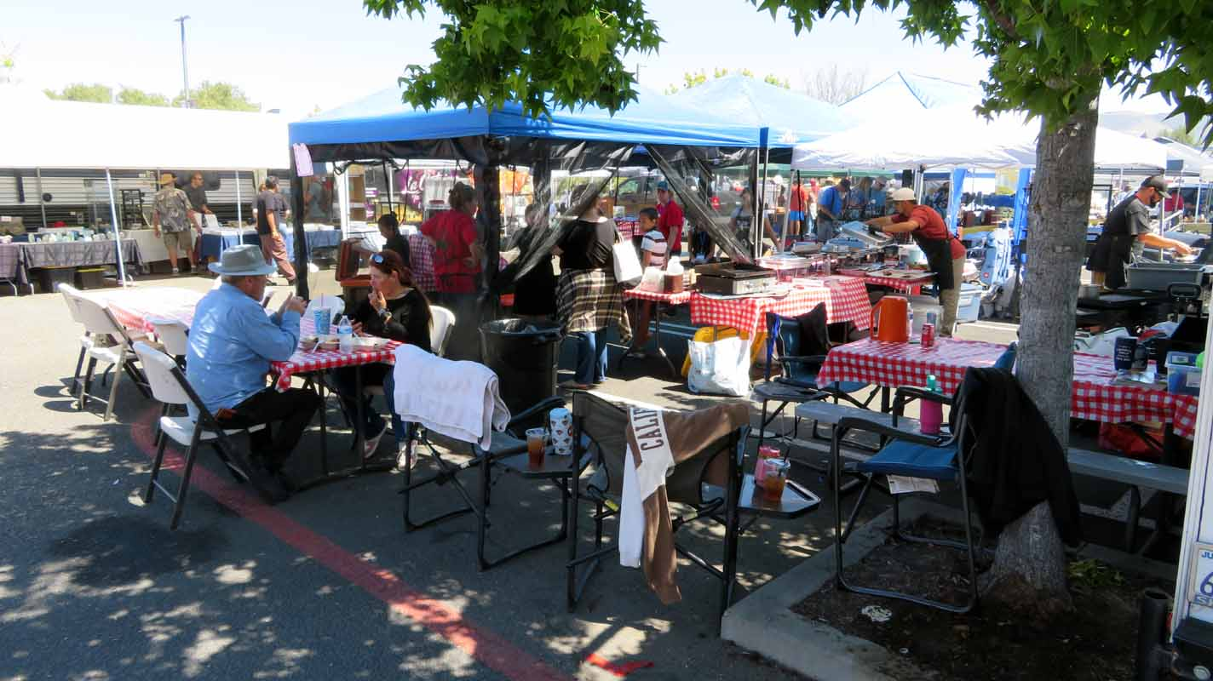
The crowds were awesome all three days! Our advertising worked this year!
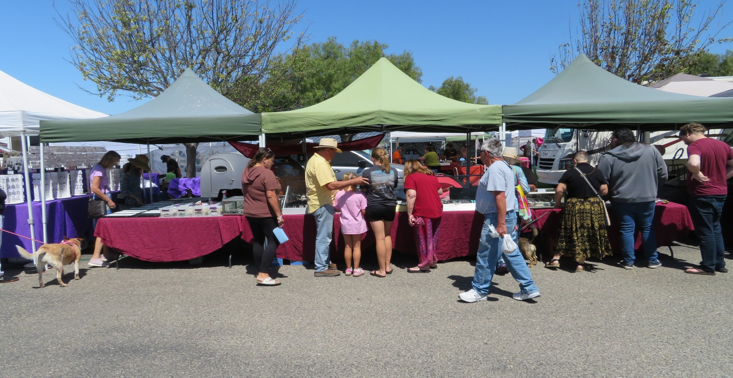
The parking lots were always full!

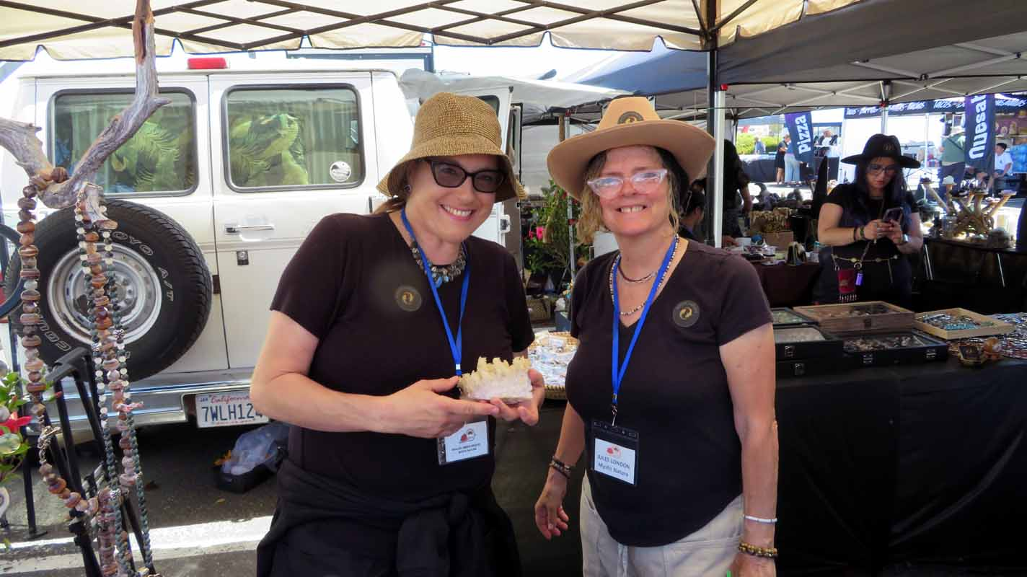
Nipomo’s own rock shop! Mystic Nature!
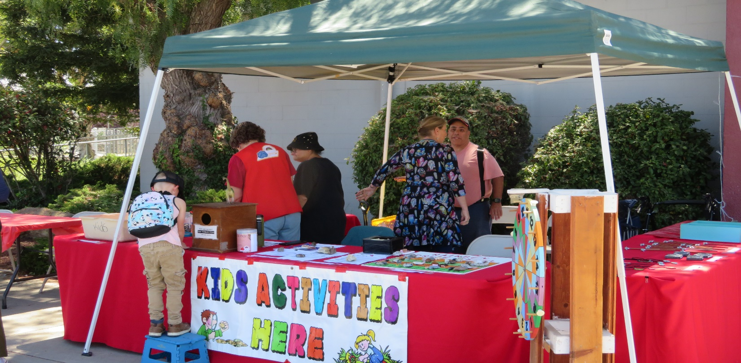
This activity is always a big hit!

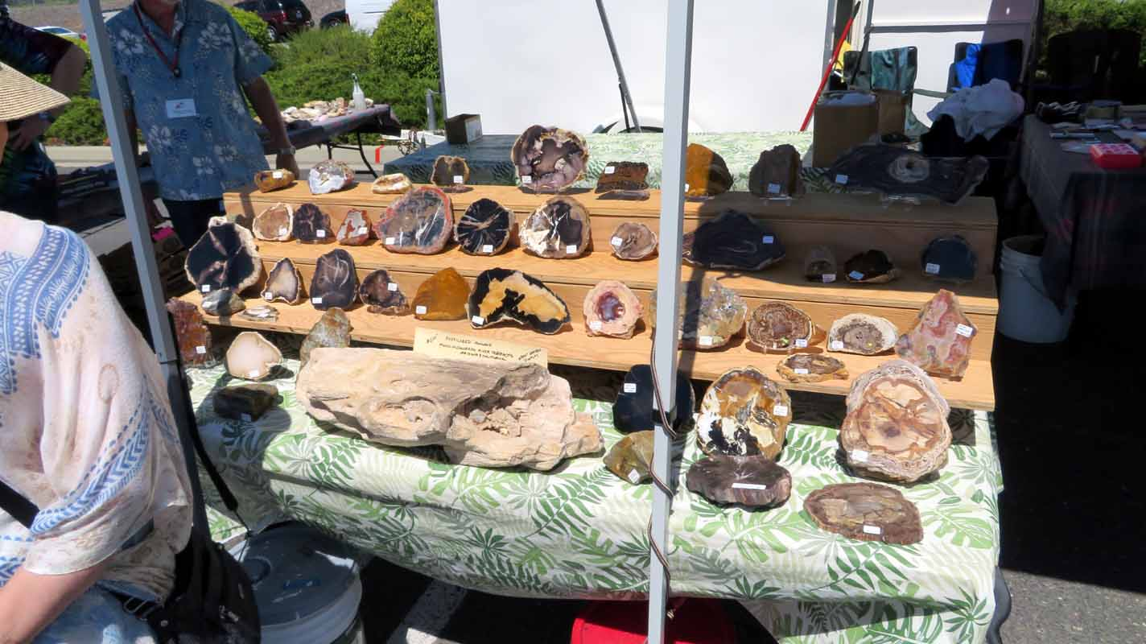
We have a huge variety of products presented to visitors. You can find almost anything concerning rocks!
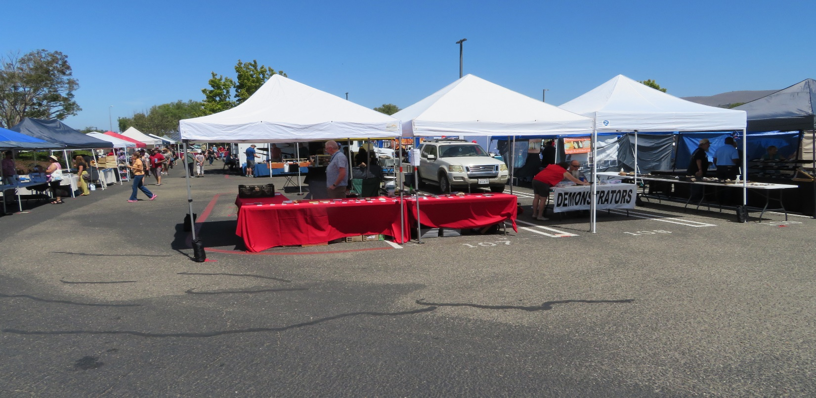
The addition of the silent auction booth was a brilliant idea, and it made money!

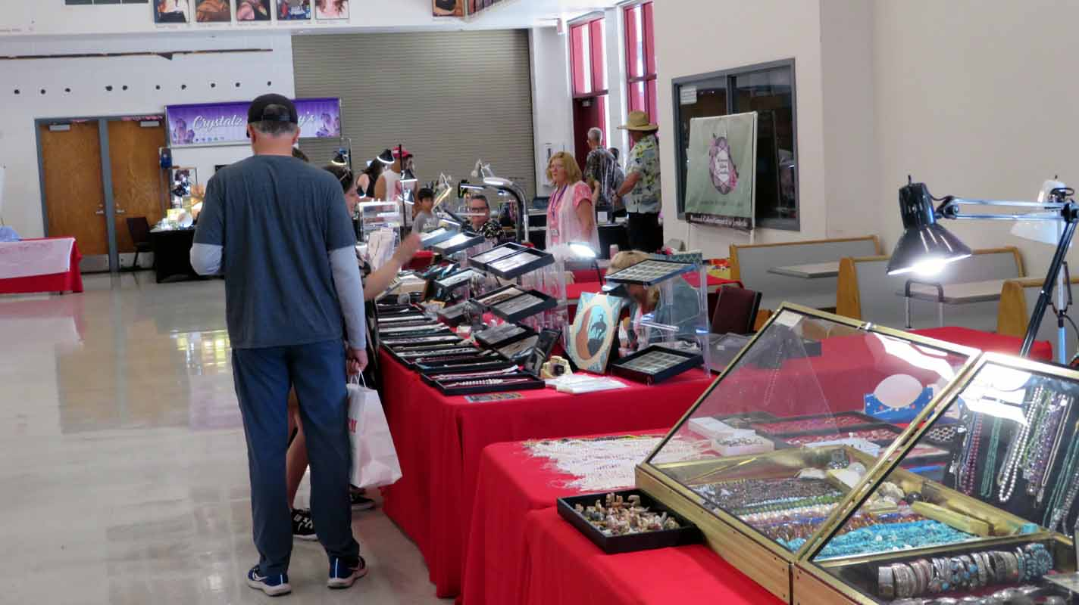
The 16 inside dealers had plenty of room and the lights stayed on. They all left happy!
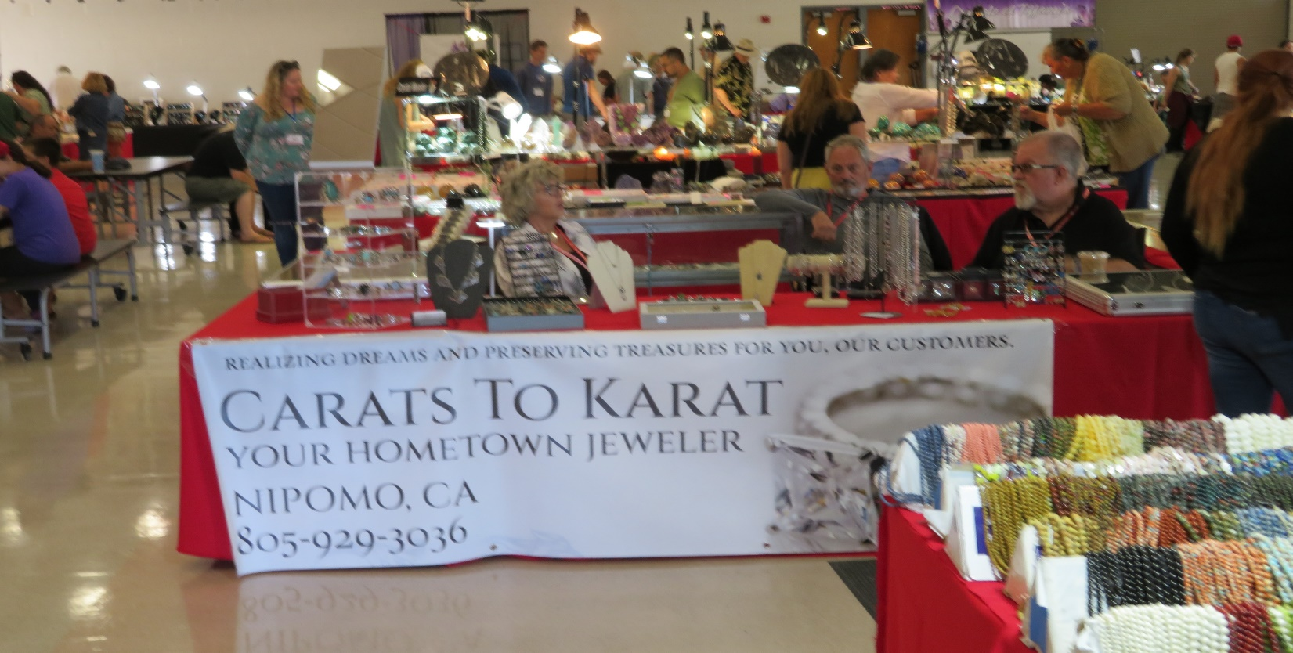
Another Nipomo vendor, from next door to Mystic nature. Look at the crowd!

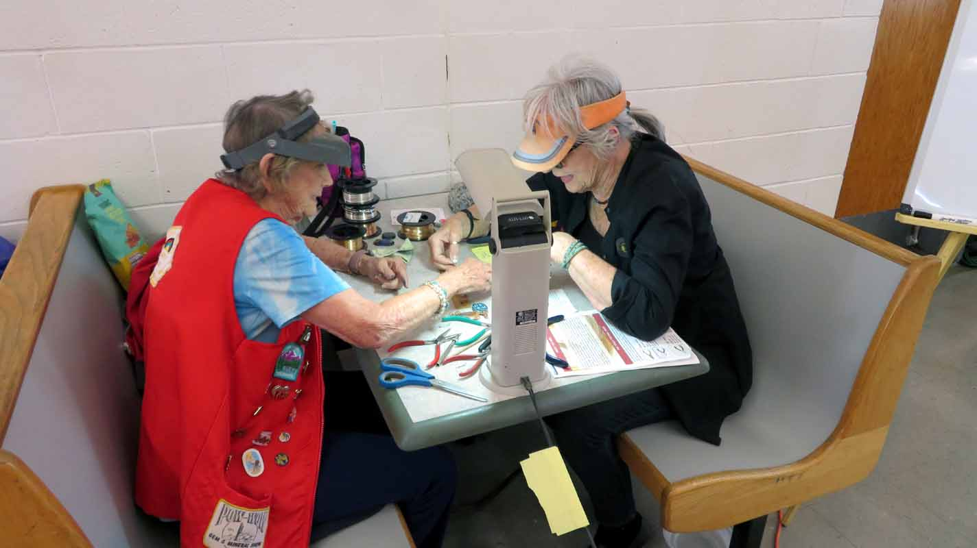
Several People learned basic wire wrapping from Jeannie, She was a hit!
We have had another successful show this year, but it came with a lot of hard work!
- Renae Sutcliffe deserves a Gold Medal!
- The OMS Board did a good job of preparing and planning.
- Michelle did a supper job of advertising.
- The Highway sign team got the job done.
- We had non-members pitching in such as Robert Evers and Kathy Holst’s family.
- All the while there was disturbance from having to move the Sea Train.
- The coffee solution was genius!

There where problems that need to be solved.
The Display Case lights were left on all night on Thursday.
An on/off switch must be added to each case not having one.
The sound system is antiquated. Dave Lambert suggested the acquisition of a new Blue Tooth system. Needs follow up.
We needed more electric cords due to added vendors.

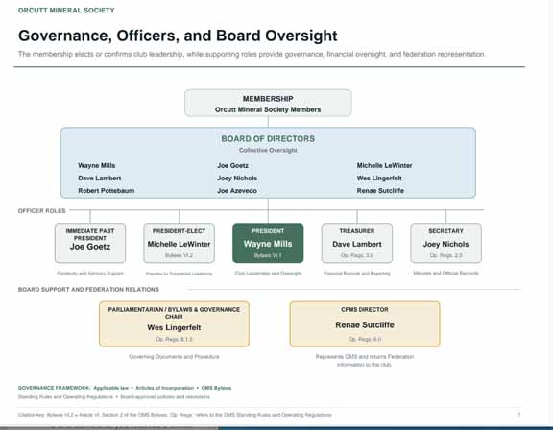

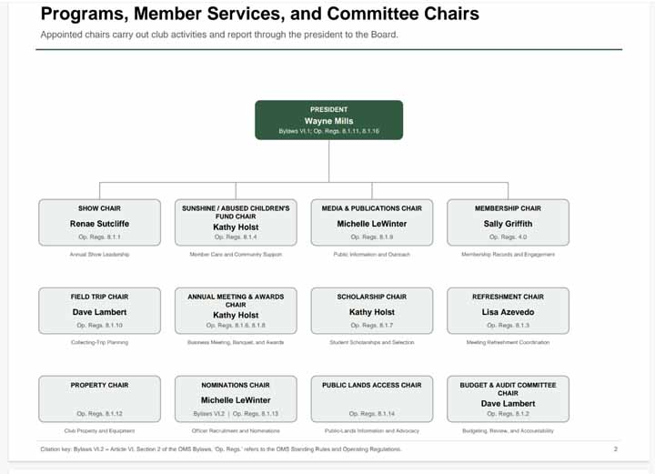

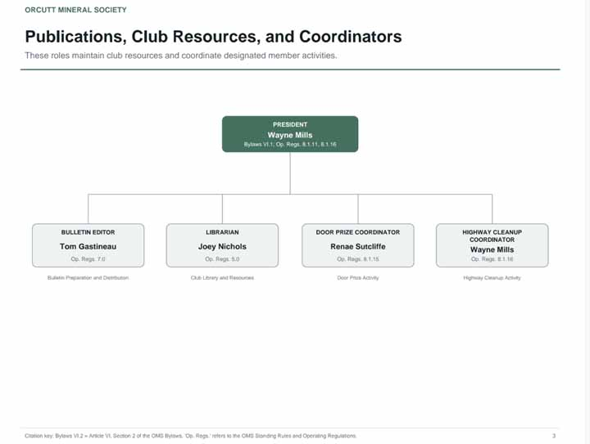

GIVEN THAT THIS CORPORATION HAS BEEN AROUND SINCE 1958, THERE HAVE BEEN TIMES WHEN I THOUGHT IT WOULD FOLD. AFTER THIS YEAR AND WITH ALL THE NEW MEMBERS COMING ON BOARD I AM ENCOURAGED AND OPTIMISTIC ABOUT OUR FUTURE. MY HOPE IS THAT THE NEW MEMBERS WILL ROLL UP THEIR SLEEVES AND MAKE US MORE SUCCESSFUL IN THE FUTURE. WE CAN DO IT!
THE END

